EARLY WARNING BULLETIN FOR FOOD SECURITY

No. 2015/10 IN THE GAMBIA Period: August 1-10, 2015

 Government of The Gambia | Produced and Published by The Gambia National Multidisciplinary Working Group  Focal Point: Department of Water Resources  TEL: (+220) 4227631 / 4224122 / 8905229 - FAX: (+220) 422 50 09  E-MAIL: dwr@mofwrnam.gov.gm / WEB: www.mofwrnam.gov.gm | 

1.0 METEOROLOGICAL SITUATION

1.1. SYNOPTIC SITUATION

On average, the surface position of the ITD (imaginary boundary that separates south-westerly warm and humid winds from the north-easterly cold and dry winds) fluctuates over Central Mauritania, stretching towards Northern Mali, Niamey, Chad and onto Sudan. Convective activities were observed over Ivory Coast, the Sene-Gambia region, Burkina Faso and Nigeria resulting to thunderstorms and rains recorded in these regions. However, dust/haze spread over northern Mauritania with visibility ranging from 1500-3000m during the middle parts of the dekad.

1.2 WEATHER SUMMARY FOR THE GAMBIA

Variably cloudy, warm and humid atmospheric conditions prevailed, with mainly light rain and thunderstorms mostly over the eastern parts of the country.

1.3 OUTLOOK FOR THE NEXT DEKAD (August 11-20, 2015)

Variably cloudy, humid and warm atmospheric conditions combined with scattered to widespread thunderstorms sometimes with strong winds, accompanied by moderate or heavy rains is expected to prevail over the country during the first 5 days and towards the end of the dekad.

2.0 AGROMETEOROLOGICAL SITUATION

2.1 RAINFALL SITUATION

The rainfall situation during this dekad was favorable throughout the country. In the Western Third, Kerewan recorded the highest dekadal total of 114.7mm, in the Middle Third Jenoi recorded the highest dekadal totals of 86.3mm and Fatoto recorded the highest dekadal total of 101.5mm in the Eastern Third of the country. Whilst Basse recorded the lowest dekadal total of 26.9 mm, followed by Sibanor 40.8mm (figure 1a).

Seasonal rainfall totals recorded so far varied significantly. The highest seasonal rainfall total countrywide was recorded at Yundum Airport (503.8) in the Western Third. Whereas Banjul in the same Third recorded a seasonal total of 187.6mm.In the Middle Third Sapu recorded the highest of 485.6mm, whereas Kaur in the same Third recorded a seasonal total of 184.6mm.In the Eastern Third Basse and Fatoto recorded seasonal totals of 405.9mm and 347.6mm respectively (Figure 1b).

Figure 1a: Rainfall dekadal totals 1ST –10th August 2015.

Figure 1b: Rainfall Seasonal totals from May 1st 2015 – August 10th 2015.

2.2 RAINFALL COMPARISMS

The Country average as of 10th August 2015, stands at 350.9mm, 70% above the country average for last year (10th August 2014; 206.3mm), and 4% below the long term mean (1981-2010; 365.8mm). Meanwhile, seasonal rainfall totals for individual stations shows that some stations are still in the deficit when seasonal totals are compared to the long term means of these stations (Banjul, Kaur and Janjanbureh).

2.3 Temperature

Average temperatures across the country vary between 27ºC and 28ºC. Meanwhile, maximum temperatures varied between 32ºC and 34ºC over the entire country, whilst minimum temperatures fluctuated between 21ºC and 24ºC

2.4 Winds

Winds were light to moderate with a maximum speed of 42km/h over Yundum.

2.5 Sunshine Duration
Isolation during the dekad was between 5 to 7hours

2.6 Relative Humidity

Highest average relative humidity across the country was above 70% indicating an increased level of moisture in atmosphere. With high temperatures the situation is ideal for rainfall occurrences but unfavorable for asthmatic patients.

3.0 Hydrological Situation

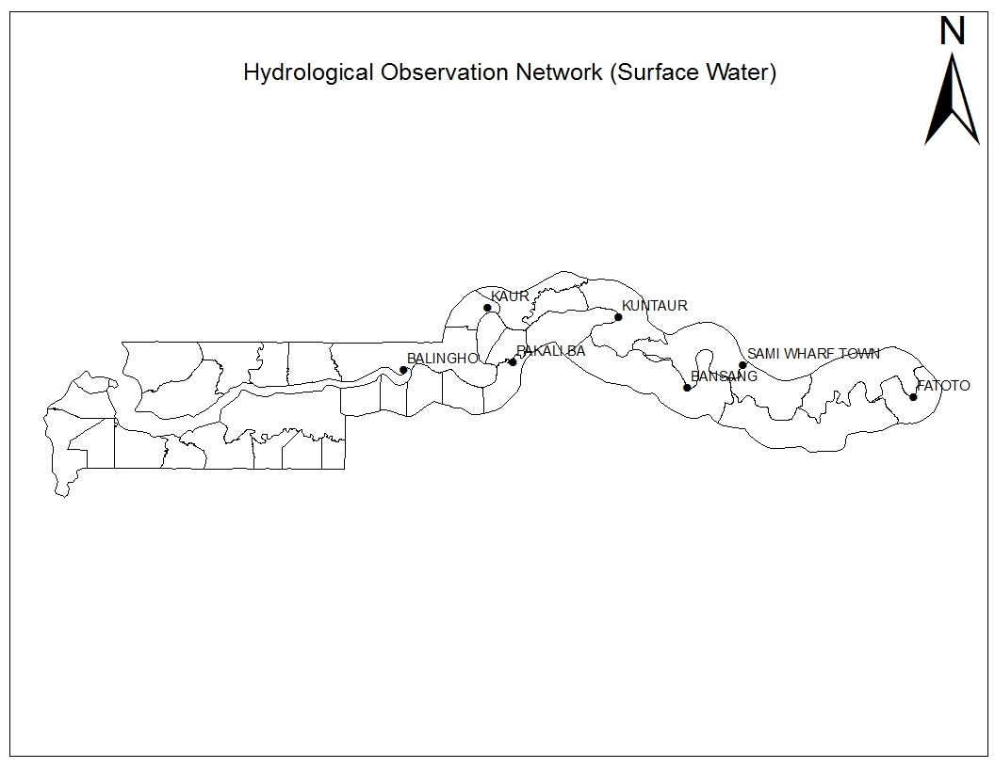
Max: 1.66m
Min: 0.25m
Sal: 24.86 PSU

Max: 2.51m
Min: 1.41m
Sal: 9.23 PSU
Max: 1.95m
Min: 0.64m
Sal: No
Max: 1.62m
Min: 0.85m
Sal: 6.73 PSU
Max: 2.73m
Min: 1.67m
Sal: No

Max: 32.763/s
Min: -32.467/s

Figure 2: the map of the Gambia showing the Hydrological Observation Network

Comments:

According to the data presented above and when compared to the previous data, it can be observed that all the stations recorded increased maximum levels and increased minimum water levels, this could largely be attributed to the increased run-offs within the river basin that flows into the river as rainfall increases in quantity and intensity.

On the salinity front, all the stations that lie within the seasonally saline region (i.e. Ballingho, Pakaliba and Kaur) recorded a significant decline in salinity levels beginning from early/mid-July. However, Balingho recorded highest of 24.86 PSU as seen in the figure above.

Rising water levels were also observed at Basse, Dampha Kunda (discharge), Sami Tenda and Fatoto.

Please note: Balingho’s water level max was 1.61m and min: 0.13 instead of Max: 2.96m and min: 0.14 as reported in the in the July 1-10 Bulletin.

4.0 AGRICULTURAL SITUATION

West Coast Region
N/A

North Bank Region
The main Agricultural activity in this region is weeding. Groundnuts (Philippine pink variety) are at flowering and pegging stages. Other groundnut varieties, millet, and rice are all at their vegetative stages. Generally with the continuation of the current rainfall trend there is high hope of bumper harvests in this region.

Lower River Region
N/A

Central River Region North
The Agricultural situation in this region too varies, sowing is almost completed for some farmers in the Uplands, while others have started weeding and crops are doing well. In the Lowlands, Nursery preparation is completed and transplanting is in progress. In the Swampy areas ploughing is almost finished and broadcasting has started. However, there were some flooded fields in the Tidal Zones of Fulla Kunda and Sukuta and farmers affected resorted to replanting.

Central River Region South
Agricultural activities in this region showed little difference from that of the past dekad. Activities are ongoing for both uplands and lowlands, farmers involved in dry season rice planting in the Tidal areas are on bird scaring, harvesting and threshing, while those who are involve in rainy season rice planting are on land preparation and transplanting. In the upland fields, early planting of legumes and cereal crops have been completed for some and few are busy ploughing for water melon and Cowpea fields. Upland rice cultivation is also in progress

Upper River Region
In this Region, activities varied, some farmers have finished applying fertilizer and are busy weeding while others are still on fertilizer acquisition. Most crops are at their vegetative stage and good looking. Planting of late millet and Cowpea is in progress for some farmers.

4.1 COMMODITY PRICES

Table 1: The table below show Agricultural Commodity Average Prices per KG (in Dalasi) of selected markets - Date: 13/08/15
Comodities | Banjul | Bakau | Serekunda | Brikama | Latrikunda | Tipper Garage | Bansang | KerrPateh | Farafenni | Brikamaba | Sami | Wassu | Average
CEREALS
Maize | 24.40 | 24.90 | 21.10 | 23.90 | 24.00 | 19.70 | N/A | 14.00 | 15.00 | 14.50 | 15.00 | 14.65 | 19.20
Millet | 23.60 | 24.80 | 21.80 | 25.91 | 24.00 | 27.50 | 17.02 | 14.50 | 13.00 | 15.00 | 15.00 | 14.00 | 19.68
Sorghum | 24.10 | 23.70 | 22.10 | 24.60 | 23.20 | 21.10 | N/A | 14.50 | 15.00 | 13.00 | 14.75 | 14.50 | 19.14
Local Rice | 28.00 | 28.00 | 28.00 | 28.00 | 28.00 | 28.00 | 26.00 | N/A | 26.00 | 26.00 | N/A | 26.00 | 27.20
Broken Rice | 24.00 | 24.00 | 24.00 | 24.00 | 24.00 | 24.00 | 26.00 | 25.00 | 26.00 | 26.00 | N/A | 25.00 | 24.73
Long Grain Rice | 26.00 | 26.00 | 26.00 | 26.00 | 26.00 | 26.00 | N/A | N/A | 28.00 | 28.00 | N/A | 28.00 | 26.67
Findo | 98.40 | 82.10 | 91.00 | 95.00 | 88.00 | 81.30 | N/A | N/A | 75.00 | N/A | 75.00 | N/A | 85.73
VEGETABLE
Cabbage | 46.69 | 46.20 | 47.70 | 42.50 | 43.15 | 42.30 | 32.55 | 30.00 | 35.00 | 30.00 | 34.88 | 31.42 | 38.53
Lettuce | 38.60 | N/A | 35.60 | N/A | N/A | 40.00 | N/A | N/A | N/A | N/A | N/A | 166.66 | 70.22
Large epper (Hot) | 126.95 | 129.50 | 128.10 | 125.00 | 128.40 | 130.90 | 106.66 | 105.00 | 100.00 | 110.02 | 102.00 | 100.00 | 116.04
Okra | 81.90 | 74.60 | 82.75 | N/A | N/A | 75.95 | 75.00 | N/A | 70.00 | 78.95 | 70.00 | 72.00 | 75.68
Egg plant | N/A | 38.50 | 41.70 | 39.26 | 34.30 | 47.20 | 30.00 | 30.00 | 35.00 | 38.46 | N/A | 40.00 | 37.44
Wonjo | 135.40 | 132.60 | 134.00 | 133.96 | 133.94 | 133.92 | 96.25 | 90.00 | 89.33 | 86.66 | 89.61 | N/A | 114.15
Bitter tomato | 43.76 | 43.20 | 40.00 | 43.10 | 46.45 | 48.30 | N/A | 40.00 | 42.00 | 44.82 | 41.57 | 42.50 | 43.25
Tomato big size | 42.10 | 40.00 | 46.97 | 45.80 | 49.70 | 44.50 | 47.62 | N/A | 50.00 | 48.37 | N/A | 48.33 | 46.34
Imported Onion | N/A | N/A | N/A | N/A | N/A | 40.00 | N/A | N/A | N/A | 35.00 | N/A | 35.00 | 36.67
Local Onion | 30.00 | 30.00 | 30.00 | 35.00 | 30.00 | 35.00 | 30.00 | 25.00 | 30.00 | 30.00 | 35.00 | 30.00 | 30.83
ROOTs & TUBERS
Carrot | 65.8 | N/A | 63.89 | N/A | 61.9 | 50.3 | N/A | 53.00 | 48.91 | 57.69 | N/A | 50.00 | 56.44
Cassava | 43 | 50.7 | 41.4 | 40.1 | 41.7 | N/A | 34.05 | 30.00 | 35.00 | N/A | N/A | N/A | 39.49
Sweet Potato | 53.31 | 52.9 | 44.5 | 47.8 | 49.23 | 45.97 | 35.00 | 35.00 | 40.00 | 37.78 | N/A | 30.00 | 42.86
Irish Potato | 35 | 35 | 35 | 40 | 35 | 40 | 40.00 | 40.00 | 40.00 | 35.00 | N/A | 35.00 | 37.27
Fruits, Nuts and Legumes
Mangoes | N/A | N/A | 46.78 | N/A | N/A | N/A | 30.00 | 20.00 | 20.00 | 25.00 | 30.00 | 30.00 | 28.83
Lemon | 46.50 | 45.00 | 45.10 | 40.50 | N/A | N/A | 31.74 | N/A | 34.00 | N/A | N/A | N/A | 40.47
Pumkin | N/A | N/A | 46.60 | N/A | N/A | N/A | 40.00 | N/A | N/A | N/A | N/A | N/A | 43.30
Banana | 45.00 | N/A | 40.00 | 45.00 | 40.00 | N/A | N/A | N/A | 35.00 | 30.00 | N/A | 25.00 | 37.14
Decorticated G/Nut | 53.00 | 46.70 | 38.80 | 49.30 | 55.60 | N/A | 53.33 | 35.00 | 30.00 | 30.00 | 35.00 | 28.00 | 41.34
Undecorticated G/nut | N/A | N/A | 49.50 | N/A | N/A | 50.00 | N/A | 22.00 | N/A | 20.00 | N/A | 30.00 | 34.30
Beans | 45.00 | 35.00 | 40.00 | 51.00 | 50.00 |  | 45.00 | 35.00 | 40.00 | 40.00 | 30.00 | 25.00 | 39.64
LIVESTOC
Beef Meat&Bone | 175.00 | 175.00 | 200.00 | 175.00 | 185.00 | 200.00 | 150.00 | 150.00 | 150.00 | 140.00 | 150.00 | 140.00 | 165.83
Beef Steak | 225.00 | 200.00 | 225.00 | 200.00 | 195.00 | 200.00 | 170.00 | 180.00 | 200.00 | 150.00 | N/A | 160.00 | 191.36
Mutton | 200.00 | N/A | 225.00 | 200.00 | 200.00 | N/A | N/A | 200.00 | N/A | N/A | 150.00 | 175.00 | 192.86
Source: Planning Services Unit (DOA)

4.2 CROP PROTECTION
N/A

4.3 LIVESTOCK

The Livestock situation in the Country has improved tremendously as a result of adequate feed and water. Animals in the hardest hit regions during the long dry season e.g, LRR and NBR are doing very well in terms of health and production. The clinical figures for West Coast Region are 121 heads of cattle of which 60 were vaccinated against Haemorrhagic Septicaemia (H/S) and 28 Sheep were treated.

In the Lower River Region 33 horses, 165 heads of cattle of which 71 were vaccinated against Black Quarter (BQ) 91 goats 73 Sheep 17 donkeys and 11 Rabbits were treated. In Central River Region South, 35 Sheep of which 23 were vaccinated against Pasteurellosis, 23 goats, 3 horses and 4 donkeys were treated.
In the Upper River Region 147 Sheep, 30 goats, 5horses, 4 cattle were treated. Central River Region North 32 goats, 61 Sheep, 125 heads of cattle, 17 donkeys and 33 horses, were treated. In the North Bank Region 205 heads of cattle, 168 sheep, 62 goats, 73 horses and 55 donkeys, were treated.
It is important to note that the majority of the clinical figures reported in this dekad were prophylactic treatment not disease cases. Nonetheless, monitoring will certainly continue.

4.4 FISHERIES
N/A

5.0 NATIONAL DISASTER MANAGEMENT AGENCY (NDMA)
N/A

6.0 NATIONAL ENVIRONMENT AGENCY (NEA)
N/A

Banjul August 11th 2015
National MWG of The Gambia

Composition of MWG:  Department of Water Resources  Planning Services - Department of Agriculture (DOA)  Communication, Extension & Education Services - DOA  Animal Health & Production Services - DOA  Plant Protection Services - DOA  National Environment Agency | Direct your comments and questions to:  The Director  Department of Water Resources  7 Marina Parade, Banjul  The Gambia  Tel: (+ 220) 422 76 31 / 422 41 22 / 890 52 29  Email: dwr@mofwrnam.gov.gm

